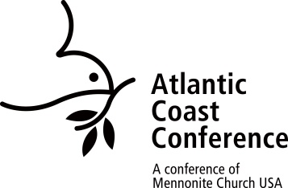**Renewal of Credentials for ACC Ministers**

(Ordained Active, Ordained Active without Charge, Licensed for Specific Ministry)

**Atlantic Coast Conference**

*To be completed by the minister and reviewed by the conference minister*

*A digital copy of this form is available at* a *atlanticcoastconference.net/recredential*.

Introduction: All ministers of Atlantic Coast Conference have their ministry credential renewed every three years. ACC’s Ministerial Leadership Committee has developed a regular review process that encourages all ministers to be life-long students, open to study and improve their knowledge and skills for ministry. As a part of the review carried out by conference ministers for renewal of ministerial credentials every three years, each minister should show evidence of having worked at continuing education.

The following questions are an attempt to provide accountability for the above expectations.  *If the space allotted for response is not adequate, please include the additional information on a separate page and attach to this form*. The form is **due in the ACC office by September 19, 2025.**

Minister Name: ____________________________________________ Date: ________________

Ministry Title & Organization: ____________________________________________________________

Renewal of ordination for : ____ Oversight Ministry ____ Chaplaincy

____ Pastoral Ministry ____ Education

____ Counseling Ministry ____ Other:______________

1. Please list the studies you have completed in the last three years. List any studies you are currently enrolled in. If you developed and/or taught a course of study, please indicate such. If you know the CE unit/s or the college/seminary credit value for each course, please indicate.

Classes, Seminars, or # of Credits

Date Workshops Attended Sponsored by or CEUs

2. List some ministry related books that have impacted you during the past three years.

Title Author/Publisher

3. List volunteer involvements outside the congregation or ministry you serve with (church-wide or community-based) during the last three years.

4. What courses, seminars, workshops, or disciplines will be part of your Ministry Growth Plan for the next three years or beyond? You may want to discuss these decisions with your conference minister.

5. Feel free to name any accountability you wish to receive or expectations you bring to your future development, either from the congregation or conference staff, in order to achieve your continuing education goals.

6. Record of conference attendance – All active pastors holding ACC credentials are voting delegates to conference. In the last three years, did you attend:

____ one, ____ two, or ____ three of the ACC Spring Assemblies?

7. Describe your participation with your appointed cluster group. If not participating, please explain why.

8. What spiritual disciplines are you currently practicing on a regular basis? Ministry is more than academic development, the soul of the person is important for cultivating healthy spiritual living.

8. What suggestions do you have for improving the credential renewal process?

**To be completed by conference ministry team member**

9. I recommend that the credentials of the minister named on this form be renewed.

____ Yes ____ No

Signature of conference ministry team member _____________________________________________

5/30/25 revision, bam