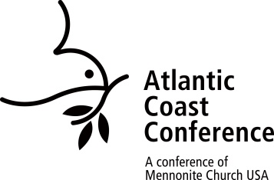**Renewal of Credentials for ACC Retired Ministers**

(Ordained Active, Ordained Active without Charge, Licensed for Specific Ministry)

**Atlantic Coast Conference**

*To be completed by the minister and reviewed by the conference minister*

*A digital copy of this form is available at* *atlanticcoastconference.net/recredential*.

Introduction: All ministers of Atlantic Coast Conference have their ministry credential renewed every three years. This includes ministers holding a retired credential. ACC’s Ministerial Leadership Committee has developed a connection process that helps conference staff keep in touch with all retired ministers.

The following questions are an attempt to provide that connection.  *If the space allotted for response is not adequate, please include the additional information on a separate page and attach to this form*. The form is **due in the ACC office by September 19, 2025.**

Retired Minister Name: ____________________________________________ Date: ________________

Home address: _________________________________________________________________________

Email address: ____________________________________________ Phone: ________________________

Congregation: _____________________________________________

1. Would you like to keep your retired minister status which allows you to perform limited ministerial functions, by completing this regular review process, including the completion of background checks?

___Yes I would like to keep my retired status

___No I am giving up my retired status

2. List some faith-related books that have impacted you during the past three years.

Title Author/Publisher

2. List any volunteer involvements in or outside the congregation during the last three years.

3. What spiritual disciplines are you currently practicing on a regular basis?

4. How have you used your ministry experience during your retirement?

5. How have you used your retired credential during the last three years?

6. Would you appreciate a follow up conversation with conference staff?

7. What suggestions do you have for improving the credential renewal process for retired ministers?

**To be completed by conference ministry team member**

8. I recommend that the credentials of the minister named on this form be renewed.

____ Yes ____ No

Signature of conference ministry team member _____________________________________________

6/24/25 revision, bam